<Project Name>
<Project Name>

Author
<Project Name>

Individual Design Approach

Project Partners: Mr. John-Ross Torre, Jacobs Engineering Group Inc.

Demonstrator: <Catherine Hatch>

Academic Supervisor:
Sally Male

Group Meeting Day and Time: Friday 12 midday

Word Count: 1572

Word Limit: 2500

Version <1.0>

Table of Contents
1. Introduction 3
1.1 Goals 3
1.2 Purpose 3
1.3 Scope 3
1.4 Definitions, Acronyms, and Abbreviations 3
1.5 References 3
2. Individual responsibility and contribution 4
3. Task Methodology/Approach 4
3.1 The method of risk identification 4
4. Risks 5
4.1 General 5
4.2 Business 5
4.3 Operability 5
4.4 Maintainability 6
5. Discussion and Evaluation 6
6. Appendices 7
6.1 Appendix A 7
6.2 Appendix B 10

Solar Generation for Remote Boreholes
Individual Design Approach

Introduction

Goals
Jacobs Engineering Group has employed Team Power to undertake a project for a mine near the town of Newman, in Western Australia, and the main goal of the project is to provide power to three pumps in a bore field located 10 km from the mine site. The proposed power system must operate and supply constant power 24 hours a day seven days a week. The mine has opted Team Power to design a cost-effective method to power the pumps while also maintaining a constant supply.

Purpose
The purpose of this document is to analyse potential risks which may exist in the project. All projects have risks, if a potential risk of the project is not identified early, then the project will be at a high risk to complete. This report is to identify potential risks and make recommendations for further design. Due to risk identification, the team design proposal can be modified and improved.

Scope
This document will discuss the main method of risk identification and will divide risks into some types. Besides, this document will list risks as many as possible. In this way, potential risks of team design approach can be reduced and the reliability of project design can be increased.

Definitions, Acronyms, and Abbreviations
PMBOK | Project Management Body of Knowledge

References

Individual responsibility and contribution
Shaochen Wang is a member of Team Power. In this team, Shaochen attended every group meeting, involved in requirement analysis, helped the team determine the generation and battery techniques; and will complete the risk analysis.
Minutes in Appendix A shows the proof of the involvement in every group meeting.
As can be seen in Appendix B, Shaochen was allocated to research 7/24, 90kW++ and Newman in requirement analysis. Moreover, Shaochen wrote reporting conventions section of literature review in team requirement analysis.
Before the team selected generation and battery techniques, Shaochen did some research about geothermal power and flywheel energy storage. However, these two techniques are not applicable to this project.
In the team design approach allocation, three members were allocated to design generation section by using different ways; one was allocated to do the base case; another was assigned to do the cost section; and my section is risk analysis.

Task Methodology/Approach

Project managers can plan their strategy according to the four steps of risk management. There are the four steps to manage risks efficiently in a project:
- Risk Identification
- Risk Quantification
- Risk Response
- Risk Monitoring and Control
Risk identification is an essential procedure in risk management process. For risk identification, it is the first and perhaps the most important step in the risk management process. If there is no specific risk identified, other steps of the risk management cannot be implemented. This means in a project risk analysis, project designer should identify risks before risk quantification, risk response and risk control.
Therefore, the main task of this report is to identify risks which may occur in the project.

The method of risk identification
As stated in Project Management Body of Knowledge (PMBOK), there are seven specific techniques and tools for identifying risk as follows:
- Documentation Reviews
- Information Gathering
- Checklist analysis
- Assumption analysis
- Diagramming Techniques
- SWOT Analysis
- Expert Judgment
In this report, Information Gathering Techniques is the main method to identify risks. The meaning of Information Gathering Techniques is brainstorming, interviewing, finding data from other project and root cause analysis.

Risks

General
General risk is defined as a product or result of a hazardous event or phenomenon in work place. In the company’s sense, the cost would be as cheap as possible while the whole engineering system should still function safely and be stable to meet all requirements. Therefore, reliable supplier plays an important role in a success project.
Team risk management is a model for managing projects by creating a shared product vision, focused on results, and applying methods of project risk management to manage risks. However, something possibly goes wrong when several people work together.
There are several possible risks as listed below:
1. Product quality cannot satisfy the requirements
2. Lack of communication between members
3. Loss of documents
4. Conflict between members
5. Unclear about the scope of tasks
6. Unable to meet the deadline

Business
Whether it is due to a potential flaw in a plan and a need for conflict management tools, money issue and HR issue are the most common scheduling errors companies make.
Resource over-allocation happens when works more than resources or workers’ working time exceeds the prescribed time. This means the manager assign too much work over what workers are available to do. This may impact project health and lead to a complete stop or fail of the project.
For business, there are several possible risks as listed below:
1. Money issue
(1) blow budget
(2) excess cash
2. HR issue: over-allocation of staff
3. Loss of reputation

Operability
Newman has a semi-arid climate, which means it has a hot summer and a mild winter. The temperature reaches or exceeds 38 °C (100 °F) for many days in the summer. Precipitation is sparse, but the influx of monsoonal moisture in the summer, which generally begins in December and lasts until April, raises humidity levels and can cause occasional heavy storms. Winter months are mild to warm, with daily high temperatures ranging from the 20 °C (68 °F) to 26 °C (79 °F), and low (night-time) temperatures rarely dipping below 6 °C (43 °F).
The power generation system must be suited to operate in the conditions regularly experienced in Newman. This means coping with adverse weather conditions such as high temperatures, high wind, rain, lightning strikes and dust. Therefore, some additional infrastructures should be considered such as shelter, cooling systems, dust filters or dust-resistant systems and lightning rods.
Therefore, some risks are considered as follows:
1. Fire
2. Weather
(1) lighting
(2) dust
(3) wind
(4) water damage
3. High temperature
4. Low temperature

Maintainability
The maintainability is defined as the probability of performing a successful repair action within a given time. This means that damaged components are easily fixed and do not require a technical expert, also these components must be easily accessible. Additionally, the maintainability can ensure the whole system safely operates in the remote location and harsh weather conditions.
The most important thing is to keep electrical maintainer safe when equipment overhaul. Hence, the maintenance area must be isolated from live part of equipment before maintenance. Moreover, battery storage or a backup system can ensure continuous operation, which means maintenance of the pumps does not require shutdown of the power system.
There are several risks may arise during the maintenance process as listed below:
1. Dust
2. High voltage power
3. Cost (as result of chosen design and extra infrastructure/tools)
4. Accessibility of equipment damage
5. Loss of power due to maintenance
6. Flaws in backup system

Discussion and Evaluation
Risks cannot be eliminated or eradicated completely. Each project more or less has potential risks. When a team undertakes a project, a certain degree of risk will be involved. Therefore, risk identification is a significant method to ensure project success.
Risk identification in the project is essential so as to manage and complete the project successfully. The earlier the risk can be identified, the earlier the plan can be made to mitigate the effects of the potential risks. There are a lot of tools and techniques or method available to identify the project risks. The method mentioned in this report is Information Gathering Techniques, which means brainstorming and finding similar data in historic projects. Risk identification is an iterative process, and all project team members should be involved in the project. Moreover, comprehensive and good risk identification will produce a good project results.

Appendices

Appendix A
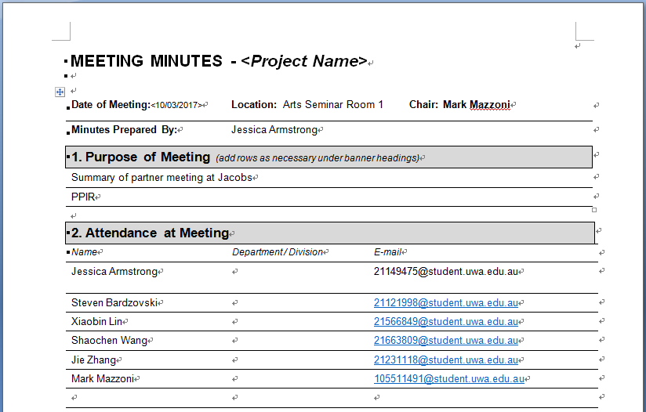



Appendix B
Table 1 Requirement Analysis Allocation
